HW1: Mid-term assignment report

*Ana Alexandra Antunes [876543]*, v2025-10-23

1 Introduction 1

1.1 Overview of the work 1

1.2 Current implementation (faults & extras) 1

2 Product specification 2

2.1 Functional scope and supported interactions 2

2.2 System implementation architecture 2

2.3 API for developers 2

3 Quality assurance 3

3.1 Overall strategy for testing 3

3.2 Unit and integration testing 3

3.3 Acceptance testing 3

3.4 Non-functional testing 3

3.5 Code quality analysis 3

3.6 Continuous integration pipeline [optional] 4

4 References & resources 4

<All remarks in this color should be removed from the final document!

This a template for the expected **content/structure**. You may use any editing tool to prepare the report (LaTeX included).

Feel free to write in Portuguese or English, but do not mix languages between headings and body…>

# Introduction

## Overview of the work

This report presents the midterm individual project required for TQS, covering both the software product features and the adopted quality assurance strategy.

<briefly introduce your application use case: name the product, if applicable; what is its general purpose, in your words?>

## Current implementation (faults & extras)

 <explain the known limitations 🡪 features that are missing or faulty but were expected! >

< if applicable: clarify which extra features did you implement. Are there relevant additions you decided to include?>

## Use of generative AI

Clarify how did you use AI-assistants for production and test code.

Be clear about the parts you prefer not to delegate.

# Product specification

## Functional scope and supported interactions

<who (actors) will use the application and for what? Explain the main **interactions;** include/explain the experience with a visual summary. >

## System implementation architecture

<briefly present the software architecture.>

<detail the specific technologies/frameworks that were used>

## API for developers

<what services/resources can a developer obtain from your project? document your API endpoints>

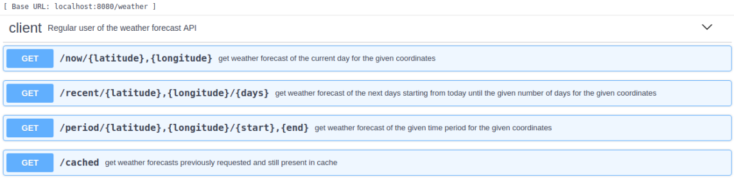

# Quality assurance

## Overall strategy for testing

[what was the overall test development strategy? E.g.: did you do TDD? Did you choose to use Cucumber and BDD? Did you mix different testing tools, like REST-Assured and Cucumber?...]

## Unit and integration testing

[where did you use unit and integration test? for what? which was the implementation strategy?]

[may add some screenshots/code snippets for clarification, but do not dump all tests here….]

## Acceptance testing

[which user-facing test cases did you considered? How were they implemented and automatized?]

[may add some screenshots/code snippets for clarification]

## Non-functional testing

[which non-functional test cases did you consider? Expected: performance study with, at least, load tests]

## Code quality analysis

[which tools/workflow did you use to for [static code analysis](https://www.sonarsource.com/learn/static-code-analysis-using-sonarqube/)?

Show and interpret the results.]

[you may add some interesting lessons learned, e.g., some code smell reported by the tool that was difficult to spot and otherwise you wouldn’t address it]

## Continuous integration pipeline [optional]

[did you implement a CI pipeline? What was the setup? Illustrate with screenshots, if applicable]

# References & resources

Project resources

|  |  |
| --- | --- |
| **Resource:** | **URL/location:** |
| Video demo | <short video-demonstration of your solution; copy into the Git folder, under /docs> |
| QA dashboard (online) | [**optional**; if you have a quality dashboard available online (e.g.: sonarcloud), place the URL here] |
| CI/CD pipeline | [**optional**; if you have th CI pipeline definition in a server, place the URL here] |

Reference materials

<If applicable: document the key components (e.g.: libraries, API) or key references (e.g.: blog post) that were helpful and certainly **would help other students pursuing a similar work**>